**IT5015D. Software Development Fundamentals**

**Assessment 3: Research Repository**

**John Meni Williams - 20210689**

This assessment represents 25% of your final grade

.

# Overview of the Software Development Life Cycle Course Registration System Project

## Stage 1: Planning

**Summary of Planning stage**

After my first 2 Assignments having been submitted:

1. Flow Chart/SDLC
2. Helpdesk Ticketing System

And with weekly class lab activities I have tried to take the skills I have learn and tried to develop them further.

I have decided to submit 3 Projects that I have worked on to show my knowledge and skills development.

**Files Submitted will be**

A Python Turtle Canvas creation  
 – “RomanTurtleAssessment.py”

A Python Student Course Registration Project that exports user input to a text file  
 - “MyStudentDB.py”

A further development of the Student Course Registration where I develop a GUI input interface  
 – “PythonGUI.py”

Note: files can be run by right clicking file and choosing “open with”……”Python”  
  
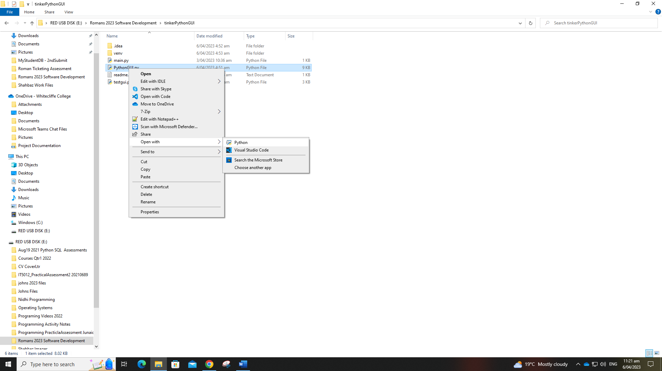

**Agile vs Waterfall –Which of them too choose…**

In the planning and processing of my Projects I used Agile as my development process with an attempt at a sequential step by step process, but which needed a lot of development changes, research, and testing along the way to get to a final outcome.

As working with Python is a weak subject matter for me in comparison to my skills and knowledge in other subject matter such as Server and Network Administration, I did struggle very much so with these Assessments.

Therefore, this is why my Python Projects have extensive “comments” within them. Not only are they for others to understand my Project functionality, in reality they are more so for my personal benefit. As if I came back to my Project after a week or two. With out the comprehensive comments I would struggle again to comprehend what I had done and why in the first place.

I need to drive harder to work more with Python on a more regular basis.

So yes lots of research, lots of testing with lots of fails.

There were times even when Python code worked but it didn’t do or perform the functionality process that I had intended.

**Purpose of this project**

As mentioned earlier I am submitting 2/3 Projects.

1. Python Turtle Canvas Diagram/Drawing
2. Python Command Line Student Course Registration System, capture import from the Command Line and export to a text file
3. Same step 2 Project but I have further developed it to launch a GUI interface for user to interact with instead of the previous method of from the command line terminal

**System context diagram**

Below is my initial flow Diagram for the planning of my Course Registration System

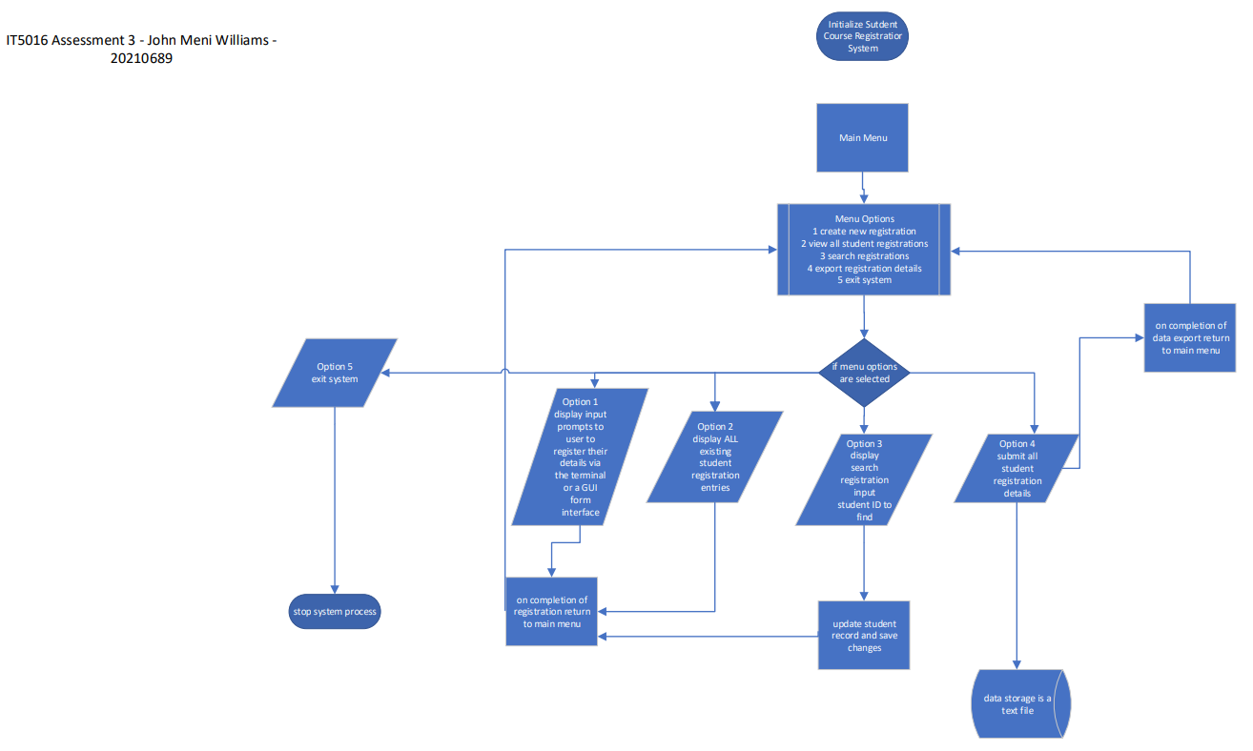

## Stage 2: Requirements Analysis

Below are what I have decided are needed for the Course Registration System

user GUI

1. interactive functional buttons
2. input text box controls
3. destination export data file

Following are a list of Objects to develop via Python code:

sample variables: “name”, “street_address”, “suburb”, “city”, “email”

defined objects for the user to input:

listbox objecst for displaying selected courses names

course_buttons: “submit”,.”reset”, “close”

list of methods in the code:

initialize __init__: the constructor method that sets up the GUI window and all the widgets/controls

add_course: method for adding a course to the list of selected courses

submit: method for writing the user's details and selected courses to a file text file on an available drive. Code may need to be edited to ensure the correct drive-letter is available with potentially a text file called “coursequery.txt” present

reset: method for clearing all the input fields in preparation for new data input or to close

## Stage 3. Solution Design

The initial planning a design was done in Visio 2003 as illustrated above but duplicated here:  


## Stage 4. Development

The actual development process began with a lot of class lectures and that led to class lab activities using various applications with varying functionality:

Scratch: <https://scratch.mit.edu/projects/703931346/>

GitHub: <https://github.com/>

Koans: <https://github.com/arachnegl/python-koans>

Turtle: <https://pythonguides.com/turtle-programming-in-python/>

<https://docs.python.org/3/library/turtle.html>

**Reflections**:

“the struggle is real…” - 2pac

As mentioned earlier I would say Programming is one of my weaker skills and knowledge sets. It requires a lot of research.

It requires understanding and continued development and utilization.

I sometimes struggled with the logic in the code and found that although the code was functional it did not do what I had intended.

## Stage 5. Testing and Deployment

As expected, the testing and deployment phase was one of the most lengthy parts to the whole of the Project Development. At times trying to debug and problem solve issues was complicated and time consuming working within the entire Project as a whole.

Even implementing “Break Points” or “commenting code” when trouble shooting and debugging was not always the best solution. I had at times needed to take part of the code I was trying to trouble shoot and put it in a Module of its own and debug from there. Once the issue was resolved I could implement the changes and solutions back into the Master Project file.

## Stage 6. Maintenance

With the Deployment of my Project comes continuous Maintenance. Mainly because once I have developed and tested the Project myself. I my think it is fully functional and working fine. But other end users once they get their hands on my Project will have their difference of opinion. Now if they were a client then I would have to re-modify the Project too their satisfaction.

Some of the changes may be if a function was using a Percentage value in a calculation, then that may need updating. Or if the Project had a data source repository that was a text file or an excel spreadsheet. That may have too, because of data size growth, be upscaled to an Access or SQL database.

## References

Instructors/Lecturers: Roman Mitch, Pinal Shah and Marina Kharitonova

Advisor: Jacqueline Joy Strom - 20230773 (fellow student)

**Resources**IT5016 Software Development Fundamentals

Digital Course Manual in Canvas

LinkedIn free student tutorials

W3schools free online tutorials

Codecademy online beginner interactive tutorials

Python.org the Official Python website that provided fundamental to advanced concepts

GitHub has a vast repository of Python code examples that can be used to be able to learn from other people's code.

YouTube - There are many Python and Tkinter tutorials available on YouTube, such as those by:  
Tech With Tim, Corey Schafer, and Sentdex.

**Online Resources**

Python.org - Official Python documentation and tutorials: <https://www.python.org/about/gettingstarted/>

TkDocs - Comprehensive Tkinter documentation:  
<https://tkdocs.com/tutorial/>

Real Python -   
Python tutorials for all skill levels: <https://realpython.com/>

Codecademy:  
<https://www.codecademy.com/resources/docs/python>

Python and Tkinter courses:  
<https://www.codecademy.com/learn/learn-python-3>  
 <https://www.codecademy.com/learn/learn-tkinter>  
  
Coursera - Python and Tkinter courses:  
<https://www.coursera.org/courses?query=python%20tkinter>  
  
Bro Code:  
<https://www.youtube.com/watch?v=VkTrrqnWjsg>

Free online training course

<https://www.hays.net.nz/it/online-learning/skills-development>

<https://www.codecademy.com/catalog>

<https://www.futurelearn.com/subjects/it-and-computer-science-courses/software-development>

<https://betterprogramming.pub/10-free-software-development-resources-for-beginners-cb2d0cafbea9>

<https://www.computer-pdf.com/tutorials-software-developer>

Turtle Graphics Links:

<https://pythonguides.com/turtle-programming-in-python/>

<https://docs.python.org/3/library/turtle.html>

<https://tinyurl.com/mtxwb82h>

<https://www.geeksforgeeks.org/python-turtle-pencolor-method/>

<https://www.futurelearn.com/info/courses/object-oriented-principles/0/steps/31483>

LinkedIn Resources

<https://www.linkedin.com/learning/topics/software-development>